Chapter 2: Design Considerations of a Buoyant Drone

# Mini Abstract

1-2 paragraph chapter description. Should generally go over contents, expectations, and results. Abstracts are usually the last part of something to be written out since it is a summary of the article, but we can use them hear to help flesh out our ideas a bit for how to structure. Final abstract should be overhauled at the end of the chapter though, the chapter dictates the abstract, not the other way around.

In this chapter, we first introduce the flight conditions and payload requirements. Next, we address the necessary physics to consider with a buoyant drone design, as well as the problem with drone controllability. Finally, with the high-level system understanding developed in this chapter, we introduce the general design of the drone.

# 

# Chapter 2 Draft

In this chapter, we first introduce the flight conditions and payload requirements. Next, we address the necessary physics to consider with a buoyant drone design, as well as the problem with drone controllability. Finally, with the high-level system understanding developed in this chapter, we introduce the general design of the drone.

## 2.1 Project Goals and Requirements

In order to best implement our solution to the drone flight time problem, goals were created in order to set parameters for what stakeholders would want in our final product. These goals were defined by the needs of Jonathan Glenn, our client at USGS, who expressed their needs for what they would want to see in a long flight time drone system. Additional goals based on what we determined were necessary to achieve requirements given by the USGS were also created. Both sets of goals were broken down into 11 system level requirements each having relevant subsystem and component level requirements related to that system. Each of the system level requirements and how we planned on addressing them will be analyzed and addressed through this section.

### 2.1.1 Minimum Flight Requirements

**STR 1.0.0** Drone Flight Time: Flight time shall be at least 30 minutes with payload.

The first and most important requirement was that of flight time. Since USGS’s current drone could only fly for 15 minutes with its payload, Jonathan Glenn expressed that a doubling of this flight time would be something that they would value in our drone. Additionally this flight time would need to be achieved under our drones maximum flight conditions, defined by STR2.0.0,Drone Speed. We aimed to meet this requirement by adding buoyancy to our system to reduce the power draw needed from the motors. This was verified via power draw testing, seen in Chapter 7.2.3.

**STR 2.0.0** Minimum Drone Speed: Drone shall be able to fly at least 5 mph in winds up to 15 mph.

This requirement addressed the maximum performance condition that Flight Time STD1.0.0 must be met under. USGS expressed that they generally travel at least 5 MPH when conducting a survey and that 15mph would be the maximum wind speed that they would collect data in. To achieve this requirement we wanted to reduce the drag on the system caused by wind by adjusting our systems shape. This was verified in our V-REP simulation, seen in Chapter 8.2.2.

**STR 3.0.0** RC Control: Drone shall respond to user commands with pitch and roll angles within ±0.1 radians and a height of 1±0.15m.

USGS expressed that they would want manual control over the drone, more specifically they would want the ability to switch to manual control if some data of interest or an obstacle appeared to its scientists. We additionally wanted to add closed loop control to the remote control to help maintain stable angles so that the system would be easy to pilot. This was verified in Matlab, seen in Chapter 6.8

**STR 4.0.0,** Autonomous Control: Drone shall maintain stable pitch/roll/height and follow a path.

USGS expressed the drone should have autonomous capabilities. They wanted to be able to use these capabilities so that the drone could fly a predetermined flight path. Additionally they wanted the system to be able to resume a given flight path if it had been interrupted in favor of manual control. This would be achieved by designing a closed loop system capable of terrain tracking by using ultrasonic sensors as well as waypoint navigation using GPS data. The design for autonomous was not completed, considerations can be viewed in Chapter 6.9

**STR 5.0.0,** Cost: Drone shall cost less than $10,000. Stretch goal of less then $6,600

USGS stated that the current drone they would pay up to $10,000 for a drone with the capabilities they requested. Additionally the drone they currently have costs $6,600 . We kept a bill of materials and made estimates as to what labor costs for manufacturing would be, but have not been able to fully verify whether this requirement would be fully met. For our analysis of system cost see Chapter 12, or our bill of materials in the appendix.

**STR 6.0.0,** Magnetometer Interference: Interference from drone shall be less than 10nT on payload

Since USGS collects magnetometer data with their drone they expressed that by reducing the interference from the drones motors too less than 10nT would be beneficial to their research, as their current drone causes high magnetometer interference. Since our drones motors would be drawing less power with our reduced effective weight our system would have a reduced electromagnetic field. We aimed to use the reduction of this field in order to achieve this requirement. This was not verified.

**STR 7.0.0,** Drone Safety: The drone, its usage, and build should be safe to all individuals involved.

As a team we needed the drone to be safe to use. This means that the drone would have a standard for safe operating procedures. Additionally the drone must be able to follow safety regulations while it is being operated. More information can be found in Chapter 11.

**STR 8.0.0.** Helium Leakage: The lift bag shall maintain 90% of its buoyancy over a one week period.

Since Helium is a limited resource and has a high price we wanted to make sure that our system would be able to retain helium over the course of a week, so that our client would be able to do all their testing over the course of several days without having to refill the system. We wanted to implement some sort of seal onto the lift bag so that it could be closed after filling with minimal leakage. Tests were conducted to measure this and it was found that we did not meet this requirement, can be seen in ChapterC 9.

**STR 9.0.0,** Legal Compliance: The drone and team shall abide by all applicable laws for drone flight.

This requirement was to ensure that our drone followed all laws and regulations so that when the system was finished no additional work would need to be done before our client could use it. To try and meet these requirements FAA regulations were checked and proper avenues for paperwork were looked into. Additionally regulations related to the Covid-19 pandemic were followed. More information can be found about legal compliance in Chapter 11.

**STR 10.0.0,** Noise Level: The drone should be quieter than 65dB at 5feet away.

The last requirement USGS gave us was that by reducing the noise level of the drone to 65dB. 65dB is the ambient sound level of an urban environment so at 65dB or lower USGS could use the drone closer to populated areas with less noise complaint. Tests were conducted to measure this and it was found that we did not meet this requirement, more information about the tests can be seen in Chapter 9.

**STR 11.0.0,** Manufacturability: The drone should be able to be manufactured with equipment within our access, further decomposed in subsystem requirements.

Our drone needs to be able to be built within the first 4 months of the senior capstone project parts II and III with an additional month and a half for testing and repairs. The requirement means that it had to be built with equipment within our team's work space, such as 3D printers, soldering equipment, and sewing machines. This requirement was to ensure that a prototype could be built. More information can be found in Chapter 12.

### 2.1.2 Minimum Flight Requirements

Our stakeholders' primary need for this project is to have a flight time longer than the many of the quadcopters and hexacopters currently used in research applications. Currently USGS uses a DJI Matrice 600 Pro, a drone that when carrying the MagArrow (a 1kg magnetometer used by USGS) has a 15 minute flight time. Due to the short flight time USGS needs to conduct 7 flights in order to conduct just one survey. USGS has expressed interest in a drone that could fly twice as long as the Matrice 600 Pro, at least 30 minutes. The 30 minutes would be achieved at the system's maximum performance specified in STR 2.0.0,Drone Speed, all motors providing maximum allowable force for the entire duration of the flight. We, however, theorised that motor usage could be lowered to the point that an even longer flight time could be achievable when the system is at minimal performance, when the motors are only exerting enough force to hover. So we set a stretch goal in STR 1.0.0,Flight Time of 1 hour. Since drones spend the majority of their power on motors providing force to counteract the system weight in order to stay airborne. Our primary method to achieve STR 1.0.0, Flight Time, was to implement a buoyant force to the drone which could reduce the effective weight of the drone. By reducing our effective weight, the motors on our drone would use significantly less power draw since the force needed to stay airborne generated from the propellers will be lower than a system with a higher effective weight. The decreased power draw would decrease the battery usage of our drone extending our flight time.

The next question to consider is what is a maximum performance scenario? According to USGS they usually fly their drone at least 5 MPH when conducting surveys. They also want to conduct surveys in mild to moderate winds up to 15MPH. These speeds give our maximum performance requirement. The drone must be able to fly at least 5MPH in a 15MPH head wind. Therefore our systems motors must be able to supply sufficient thrust to keep the drones speed and ability to maintain height even with the extra drag felt by the system in a headwind. Additionally a battery must be chosen in order to support the power draw needed by the drones motors to be at this throttle for 30 minutes as well as power the rest of the drones electrical systems for the full duration of the flight. For more information on the power draw of the systems see Chapter 7.

## 2.2 Physics of a Buoyant Drone

Adding a buoyant force to the drone comes with a variety of pros and cons due to the physics of buoyancy. First we decided to use helium as our lifting gas. Using Helium is standard practice in buoyant systems today since helium is inert while hydrogen, the only other commonly used lifting gas, is highly combustible and poses serious explosive and fire risks when used. Helium has a density of 0.164 g/L. Compared to air which has a density of 1.18g/L[13] both at STP. Since the lift force can be found with . Where ⍴1 is the density of air, ⍴2 is the density of helium, and V is volume. It is calculated using the given densities that a cubic meter helium applies 1N of lift force. Thus the volume of our liftbag was decided based on the weight of the drone and the weight of the payload we need to carry. The addition of helium to our system causes a variety of other direct effects such as creating a buoyant moment, and indirect effects such as an increase in drag due our increased surface area from the helium lift bag, and reduced electromagnetic fields due to the motors not needing to compensate as much for the systems weight. In this section we will take a look at the pros and cons that adding buoyancy to our system will cause. Then Internal equations of motion are developed. The forces acting on the system can be seen in figure 2.1 at the end of the section.

### 2.2.1 Benefits of a Buoyant Force

The most straightforward impact buoyancy has on our system is a reduction in effective weight. Since the buoyant force is applied opposite the force of gravity, these forces cancel with each other resulting in a reduction in net effective weight. In the case of an object with buoyancy the effective weight is found simply by using (2.1). Since the buoyancy is reducing the effective weight of our system the motors will need to apply less force to lift the drone. Due to the smaller lift needed, the motors have a reduced power draw. The smaller power draw of the motors, which directly causes a smaller current at the same voltage, causes a smaller magnetic field and flux to be generated[15]. This smaller flux should help to reduce the magnetic interference on the payload carried by our system. The greatest effect of the reduction of the power drawn from the motors is a decrease in battery usage. Since power needed by the motor is equal to torque times angular velocity, a smaller torque applied by the motors will require less power. This will result in a longer flight time of the system since motors are the primary power drawing component in most drone systems.

### 2.2.2 Drawbacks of a Buoyant Force

The addition of a buoyant force also has its drawbacks. The buoyant force created by the helium causes a buoyant moment between the center of gravity and the center of buoyancy. This moment will cause the center of buoyancy to always be pushed to the top since buoyancy acts opposite of gravity. Because of the buoyant moment, the center of buoyancy will be designed to sit above the center of mass. With the center of buoyancy being on top the moment becomes self correcting and holds the lift bag upright. Although this has the benefit of preventing our system from capsizing, most drones steer by tilting which is not viable with the buoyant moment since it will hold our system upright, preventing it from tilting. In order to compensate for the buoyant moment, propulsion systems are placed equidistant around the body of the drone. Each of the propulsion systems consists of a motor with a propeller at the end of a shaft connected to a servo. These servos change the angle that the motors are applying their force. The rotation from the servos in combination with operating the motors at different speeds allow the system to be steered even with the buoyant moment. Additionally this method of moving will keep our system stable with pitch and roll angles always remaining close to 0 radians. By adding this propulsion system we were effectively able to turn this drawback into a benefit to our system.

Another constraint of a buoyant system is that a lift bag with a large volume is needed in order to contain sufficient helium to generate the required lift force. The large volume of the lift bag causes the drone to have a huge frontal surface area, resulting in a large drag force applied to the drone when in motion or in high headwind conditions. The drag causes a large issue especially in respect to meeting the requirement STR 2.0.0,Drone Speed. In order to compensate for the drag, the shape of the envelope(the enclosure surrounding the lift bag) was made into an ellipsoid rather than a sphere in order to reduce drag when moving parallel to the ground. Drag on an ellipsoid can be defined by the following equations 2.2-2.4 from *Applied Fluid Dynamics Handbook[14]* where ⍴ is Air density at STP, U is Air Speed ,D is High radius, and L=Width radius.

(2.2)

(2.3)

(2.4)

From equation(2.3) it can be seen that by reducing the frontal attack area of the shape and the drag coefficient the force of drag will be reduced. From equations (2.3-2.4) it can be seen that reducing the height(D) is the most effective way to reduce both the frontal attack area of the shape and the drag coefficient. This is important since weight is a force that only acts in the axis of gravity; the reduced effective weight of the system does not give us any benefits in horizontal motion. Acceleration is defined as (2.5)where Fm is the force from the propellers and Fd is the force of drag[16]. Combining this with the drag force found in equation 2.2, it can be seen that the larger the drag we experience the smaller our acceleration will be. This is critical because velocity is defined as (2.6) where vi is initial velocity, a is acceleration, and t is time[16]. Since our acceleration will be affected by drag, so will our velocity at any given time. Therefore in order to meet STR 2.0.0, Drone Speed it is critical that we reduce drag. The envelope therefore is designed to be short and wide to maintain its volume while reducing drag. The reduced height will reduce the force of drag experienced by our drone, the smaller drag from this will increase our possible velocity allowing us to meet STR 2.0.0,Drone Speed. The width of our system is made wider in inorder keep the volume of helium contained the same, keeping our effective weight low enough to meet STR 1.0.0,Flight Time. For More information about envelope design see Chapter 3. For more information on flight time see Chapter 7.

Another factor that constrains the use of a buoyant system is the cost of helium. Helium is a nonrenewable and rapidly depleting resource resulting in a high cost. Additionally, the user would need to have a tank capable of holding the required helium which would add additional cost. The high cost is important since it is important to meet our STR 5.0.0,Cost. In order to deal with this constraint, we aimed to minimize helium loss so it can perform flights for up to a week without needing to refill. This allows users to spend time collecting data over several days without needing to be concerned about refilling the drone. In the case of helium balloons deflate because helium atoms are small enough to slip between spaces in balloon material [17]. The helium loss is the case with any material, however can be reduced with materials like mylar which have smaller gaps in their structure when compared to nylon[17].Ultimately the issue was not solved in the duration of this project. For information on how this was tested, see Chapter 9.

### 2.2.3 Equations of Motion for Internal Forces

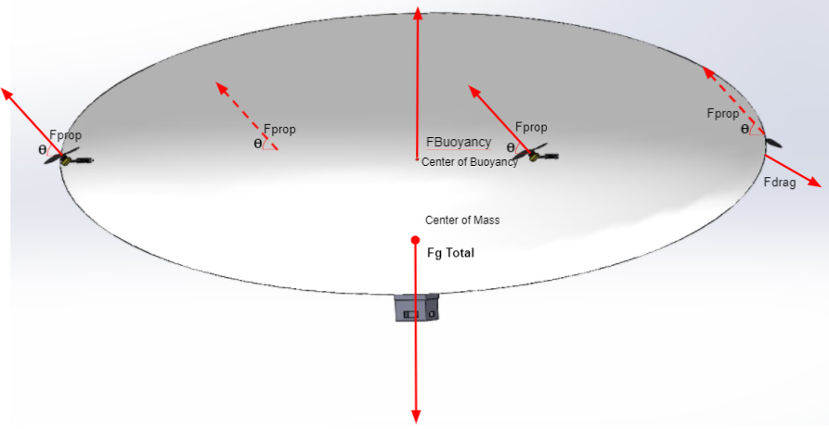

Fig. 2.1. Force Diagram of Full System

Now that the basic pros and cons of buoyancy are layed out we can start to define our full system equations of motion. These will be based on all the major force vectors in our drones body frame. The first major force vector is CMₓ, the vector from the center of mass to the center of rotation for the motor, where x denotes the motor number. Tₓ will be the scalar throttle of each motor. MₓP is the unit vector from the center of rotation for the motor to the center of the propeller. CMₓ will be a constant for each propeller decided on the mechanical design, and MₓP will vary from each motor depending on its angle and will have the value of [cos𝛳, 0, sin𝛳] where 𝛳 = 0 when propeller angle is flat on xy plane. Finally CB is the vector from the center of mass to the center of buoyancy.

With the force vectors defined we can derive an equation for the net internal force on our system. Starting with the forces created by the propellers. The position of each of the four propellers placed around the drone can be given by the sum MₓP*d + CMₓ where d is the distance between the center of motor rotation and propeller, and the force direction is given by the MₓP vector. The force from each motor is given by MₓP*Tₓ. This results in the net propeller forces to be

(2.7)

The next internal force we look at is the buoyant force, more specifically the lift force in the z axis left over after gravity and buoyancy cancel out. The force due to gravity is simply given by the mass of the drone multiplied by the acceleration due to gravity. The lift force is calculated by FB=⍴Vg where rho is the density of air and V is the volume of the lift bag. The mass of the bag and helium would be considered part of the drone mass, or the mass of helium could be included using the equation

FB=(⍴air-⍴helium)Vg. (2.8)

This results in net lift forces of

Flift=Fg+FB(2.9).

These two sets of forces defined in equations 2.7 and 2.9 can be combined in order to find the net internal force of our system

(2.10)

=(Fg+FB)+() (2.11)

Similar to forces we can derive an equation for the net moments created from internal forces. Again we start with the propellers. The moment caused by each motor can be calculated by taking the cross product of the force vector by its positional vector. This results in the moment from the motors to be defined as.

(2.12)

Next buoyancy can be examined. A moment is created between the center of mass and the center of gravity. The buoyancy moment is caused by the buoyancy force wanting to be opposite the gravity force, and can be calculated with

(2.13)

Using these two moments a total moment for the system can be found

= + (2.14)

(2.15)

With these total internal equations of motion derived for both internal forces and moments we were able to apply them when making design decisions through the process of creating the Barone. These equations were especially useful when creating the control system that would be created in order to meet STR 3.0.0,Remote Control and STR 4.0.0, Autonomous. For more information on the control system see Chapter 6.

## 2.3 General Design Overview

Based on the effects of the forces experienced by a buoyant system, as well as the high level system requirements defined by our team and USGS, we designed our system to utilize/compensate for the effects of the buoyancy while still aiming to meet the system requirements. This section will contain a general overview of this design and how it attempts to accomplish this.

### 2.3.1 System Size and Shape

As previously mentioned our primary method to achieve STR 1.0.0, Flight Time is to add buoyancy to the drone. This is accomplished by adding a lift bag to the drone's body. The goal of adding buoyancy is to reduce the effective weight of the system. In order to prevent loss of the system it was decided that the effective weight of the system should remain above 0N so it would not float away if control was lost. This became Weight Requirement STR 1.2.0:The drone shall have an effective weight of between 0 and 5 N.

In order to meet STR 2.0.0,Drone Speed it was deemed necessary to make the shape of the envelope an ellipsoid rather than a sphere. Based on the drag analysis in section 2.2.2., an ellipsoid shape would have a smaller drag force acting on it then a sphere. By keeping the drag and weight as small as possible, smaller motors could be used to control the drone. Since the motors would need to exert less force in order to counter the force of drag and weight. This would help us reach STR 1.0.0, Flight Time while also achieving STR 2.0.0,Drone Speed For more information about the drone frame system see Chapter 3.

### 2.3.2 Propulsion System

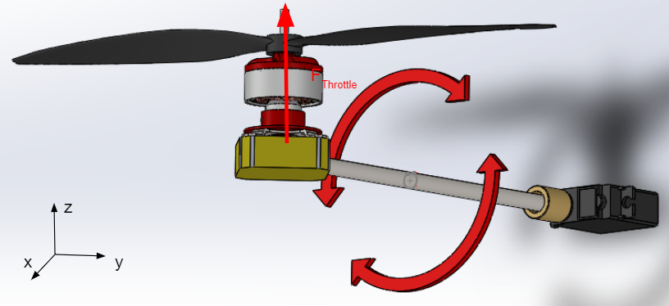

Fig. 2.2. Barone Propulsion System

In order to achieve STR 3.0.0, Remote Control we implement design features to overcome the buoyant moment discussed in section 2.2.2. Since our system cannot tilt like a normal drone due to the buoyant moment, our system uses propellers whose attack angles can be adjusted figure 2.2. We can rotate our propulsion force along the XZ axis using servos to change direction of forces output by the propellers figure 2.2; this allows us to have a controlled flight. Propellers can point up, down, forward, backwards, and anywhere in between. The propulsion system is implemented in order to be able to steer the drone even with its buoyant force keeping it upright. The propulsion system also has the additional benefit of keeping the entire system relatively stable with pitch and roll angles always remaining close to 0 radians compared to standard drones who tilt to steer. four of the propulsion systems will be mounted equidistantly around the envelope so that their forces would be applied evenly and maintain stable flight. For more information about the propulsion system see Chapter 4.

Additionally the motors are mounted far from the magnetometer payload this helps reduce magnetic interference and reach STR 6.0.0, Magnetometer Interference. Since the motors will be the largest source of magnetic interference and magnetic field is defined as (2.16) where the intensity of the field[13], The motors and payload are placed far apart from each other in order to reduce the strength of the magnetic field from the motors at the location of the magnetometer payload. This was done in order to help achieve STR 6.0.0,Magnetic Interference.

### 2.3.3 Control System

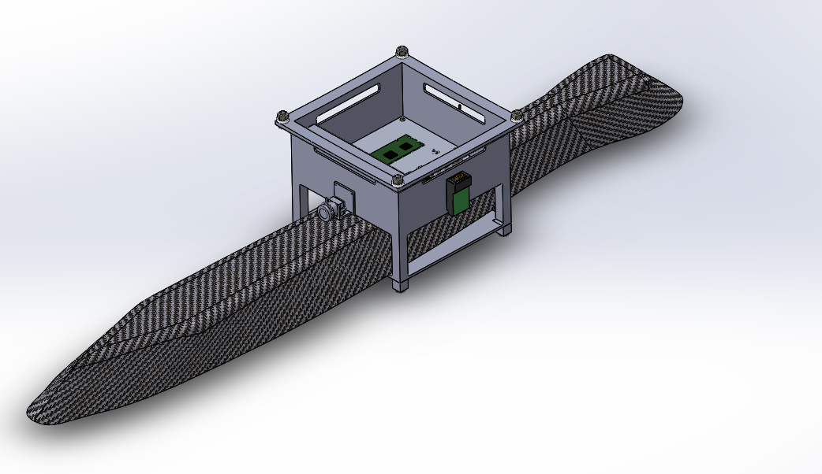

Fig. 2.3. Gondola for Electronic Housing

In order to achieve STR 4.0.0,Autonomous as well as aid with STR 3.0.0,Remote Control, we aimed to implement an autonomous as well as closed loop remote control system that would utilise various on-board sensors to maintain a stable flight in both autonomous and remote control modes. In the design of this implementation we created several subsystem and component level requirements some of which will be introduced here.

* System response STR 3.1.0: The drone shall respond to user input in < 0.5 seconds.
* RC Controller STR 3.1.1: The controller shall be capable of providing forward, turn, ascend, and descend commands
* Data Feedback STR 3.2.0: The drone shall be able to send feedback to the user
* Camera STR 3.2.1: The drone shall send camera feedback to assist in user controlled flight
* Low Battery STR 3.2.3: The drone shall send camera feedback to assist in user controlled flight
* Path Following STR 4.1.0: The drone shall be able to follow a path specified by the user in up to 15mph wind with a positional accuracy of 5m
* GPS Sensor STR 4.1.1: The sensor shall be accurate to within 5m of its location with sampling of at least 3Hz
* Terrain Tracking STR 4.2.0: The drone shall maintain a constant height above the ground, approximately 1m, and adjust height as needed. < 15% overshoot
* Ultrasonic Sensors STR4.2.1:The sensors shall be able to monitor the area in front of the drone in order to maintain constant height of 1 m.
* Barometric Sensor STR 4.2.2: The sensor shall be able to monitor altitudes above 4m for drone altitude awareness.
* Error Handling STR 4.3.0: The drone should be able to detect flight errors and compensate accordingly, specified in component section
* IMU Sensor 4.3.1: The IMU should be able to detect crashes and abnormal situations and feed the data back into the system

First an on board microcontroller needed to be implemented in order to communicate between the remote controller, sensors, and propulsion system to meet all of those subsystem and component STRs. This as well as camera, voltage alarm, GPS, barometer, IMU, remote control transceiver, battery and payload would be housed in a gondola attached to the bottom center of the envelope figure 2.3.

In order to meet STR 4.2.0,Terrain Tracking and STR 4.2.1, Ultrasonic, multiple ultrasonic sensors would be used to keep track of the distance the drone is from obstacles both in front of and below the drone. Two of these sensors; one on the bottom of the gondola, and one of the ones on the front of the drone will be tracking height. Two additional ultrasonic sensors at the front will monitor for obstacles directly in front of the drone for collision avoidance. The data from these ultrasonic sensors will be fed into the microcontroller in the gondola as inputs to the software control system to maintain stable height.

2.4 Conclusion

After requirements were defined based on the needs of USGS, a buoyant force was thought to be added to our drone system in order to reduce the effective weight. This reduction in effective weight allowed for the motors to create less power draw allowing us to achieve STR 1.0.0, Flight Time. However it was revealed through force analysis that by adding a buoyant lift bag to our drone design drag would be increased, resulting in lower achievable velocities by the drone. Therefore efforts had to be made in order to reduce the drag experienced by our system in order to achieve STR 2.0.0, Drone Speed.

# 

# Chapter Bibliography

We do have a full bibliography that should absolutely be updated with all content here. The point of the Chapter bibliography is to help keep track of citations in the Chapter since the numbering may change in the full bibliography with changes and additions. This way will isolate the sources in this section so you can cite here without having to worry about it, and can use a simple find and replace on your citations to update the new numbering when we combine everything in the final report.

[13] 36.39 -- Helium-filled balloon. (n.d.). http://web.physics.ucsb.edu/~lecturedemonstrations/Composer/Pages/36.39.html#:~:text=Helium%2C%20which%20has%20a%20mass,%2D0.164)%20%3D%201.02%20g.

[14] *Equations from Blevins, Robert D. Applied Fluid Dynamics Handbook. Repr. ed. with corrections. Malabar, Fla.: Krieger Pub. Co., 1992.*

[15] P. Virtic, P. Pisek, T. Marcic, M. Hadziselimovic and B. Stumberger, "Analytical Analysis of Magnetic Field and Back Electromotive Force Calculation of an Axial-Flux Permanent Magnet Synchronous Generator With Coreless Stator," in IEEE Transactions on Magnetics, vol. 44, no. 11, pp. 4333-4336, Nov. 2008, doi: 10.1109/TMAG.2008.2001528.

[16] Physics for Scientists and Engineers, 4th edition, by Douglas Giancoli.

[17] Anne Marie Helmenstine, P. D. (n.d.). *Why Helium Balloons Deflate So Quickly*. ThoughtCo. https://www.thoughtco.com/why-do-helium-balloons-deflate-4101553#:~:text=Helium%20balloons%20float%20because%20helium,the%20balloon%20stays%20inflated%20longer.